

**WORKSHOP**

**Dredging & Beneficial Reuse**



*Bridging the Gap to Greater Beneficial Reuse*

Wednesday, November 9, 2016

Port of Oakland

**AGENDA**

**9:00 am – 9:10 am WELCOME AND INTRODUCTIONS**

David Ivester, *Briscoe Ivester & Bazel LLP*

Jaclyn Gnusti, *Anchor QEA*

**9:10 am – 10:05 am** [**UPDATE: BENEFICIAL REUSE OPPORTUNITIES**](https://www.dropbox.com/s/qtzkhatgj1i8wlk/PANEL_BENEFICIAL%20REUSE%20OPPORTUNITIES.pdf?dl=0) **(to be updated)**

Moderator: Scott Bodensteiner, *Haley & Aldrich*

Montezuma Wetlands, Jim Levine*, Montezuma Wetlands*Cullinan and Skaggs Island, Steve Carroll, *Ducks Unlimited*Bel Marin Keys, Jeff Melby, *State Coastal Conservancy*Eden Landing Project, Megan Collins, *AECOM*

**10:05 am – 10:25 am DATA AND WEBTOOLS DEMONSTRATIONS**

[SediMatch](https://www.dropbox.com/s/pd2w8p3yt0wmwea/HUNING_SEDIMATCH.pdf?dl=0), Beth Huning, *San Francisco Bay Joint Venture*

[Herring Windows Webtool](https://www.dropbox.com/s/sq5qqsfkoo9kbsk/CHASE_HERRING%20WINDOWS%20WEBTOOL.pdf?dl=0), Dan Chase, *WRA, Inc.*

**10:25 am – 10:45 am** **BREAK** *Refreshments will be provided*

**10:45 am – 11:05 am** [**PRESENTATION: UPDATES FROM DREDGED MATERIAL MANAGEMENT OFFICE & LONG TERM MANAGEMENT STRATEGY**](https://www.dropbox.com/s/cwuy62y1r4pvpqb/ROSS_LTMS%20AND%20DMMO.pdf?dl=0)

Brian Ross, *U.S. Environmental Protection Agency*

**11:05 am – 11:25 am** [**PRESENTATION: INDUSTRY PERSPECTIVE ON OFFLOADERS**](https://www.dropbox.com/s/01eanj989q954h7/MCNALLY_OFFLOADERS_WEB%20READY.pdf?dl=0)

Jim McNally, *Manson Construction*

**11:25 am – 12:15 pm FUNDING OPPORTUNITIES**

Moderator: Josh Gravenmier, *Arcadis*

Water Resources Development Act 2016, John A. Coleman, *BPC*[Measure AA](https://www.dropbox.com/s/bc8s7pkwaztm8qb/HUTZEL_MEASURE%20AA.pdf?dl=0), Amy Hutzel, *State Coastal Conservancy*Sustainable Freight Action Plan, Richard Sinkoff, *Port of Oakland*[Funding Examples](https://www.dropbox.com/s/xznyogws15w2a6f/DOAK_FUNDING%20EXAMPLES.pdf?dl=0), Dave Doak, *U.S. Army Corps of Engineers*

**12:15 pm – 12:35 pm** [**BCDC V. U.S. ARMY CORPS OF ENGINEERS: COMPLAINT FOR DECLARATORY AND INJUNCTIVE RELIEF; 2017 CORPS O&M DREDGING PROGRAM**](https://www.dropbox.com/s/gfv8156r1aad5xv/GOLDZBAND_BCDC%20V%20USACE.pdf?dl=0)

Larry Goldzband, *San Francisco Bay Conservation and Development Commission*

**12:35 pm – 12:45 pm CLOSING REMARKS**

John A. Coleman, *BPC*

**SPEAKER BIOGRAPHIES**

**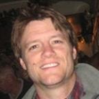Scott Bodensteiner** is a Sediment and Water Resources Specialist with 20 years of experience managing projects involving applied environmental sciences related to regulatory compliance and investigation for navigation and remediation dredging, wastewater discharges and habitat restoration and construction projects of varying size and complexity. Scott has expertise in designing and implementing water and sediment quality investigations, dredged material management planning, and dredge permitting with an emphasis on environmental toxicology, ecological risk assessment, biostatistics, sediment contaminants, TMDL support, and habitat restoration planning and monitoring. Scott received a B.S. in Environmental Toxicology from U.C. Davis, and an M.S. from San Diego State in Environmental Health Sciences.

**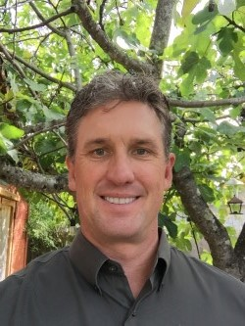Steve Carroll** is the supervising engineer for Ducks Unlimited's projects in the San Francisco Bay Area and coastal California. He was fundamental in the growth of the program and founded and supervises the Bay Area office and engineering services. He has over 20 years of engineering and restoration experience within the environmental field and has been directly responsible for the engineering design and construction of over 40,000 acres of seasonal and tidal wetland restoration and enhancement projects totaling $60 million in project funding agreements. Complementary to his restoration experience, Steve has designed and implemented fisheries projects including fish screens and ladders, has extensive experience with marine construction and the delivery of tidal restorations in shallow water environments, and with the design and implementation of ADA public use facilities. He has a strong project and construction management background, and has successfully delivered numerous wetland restoration projects of varying scope, size and complexity. Steve has also been the lead on the majority of Ducks Unlimited's dredging and

beneficial reuse projects.

**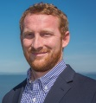Dan Chase** has more than 10 years of experience as a fisheries biologist. He earned his MS in Physiology and Behavioral Biology from San Francisco State University and BS in Conservation and Resource Studies from the University of California, Berkeley. Dan has extensive experience with fisheries related issues throughout California, and currently holds a Recovery Permit from the U.S. Fish and Wildlife Service (USFWS) for tidewater goby. His technical expertise includes fisheries ecology; fish passage evaluation; fish rescue, relocation, and monitoring; geomorphic surveying, special status species surveys; habitat assessments; and eelgrass surveys. Dan has experience with environmental permitting, from preparation through implementation of permit compliance, mitigation, and monitoring, including Endangered Species Act Section 7 and Essential Fish Habitat consultation, California Department of Fish and Wildlife (CDFW) Streambed Alteration Agreements, CDFW Incidental Take Permits (2081), and biological resource assessments prepared for the California Environmental Quality Act (CEQA).

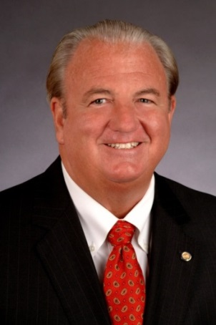**John A. Coleman** is the Chief Executive Officer of the Bay Planning Coalition, a non-profit, public benefit, membership corporation, to advocate for the balanced regulation and use of Bay-Delta resources to ensure that commerce, recreation and the environment thrive in the region. The Coalition's 175 members represent a broad spectrum of public and private Bay-Delta entities, including ports, maritime and shoreline industry, labor unions, local government, residential and commercial builders, recreational users and engineering, planning, environmental science, construction and legal professionals.

Coleman was elected in 1990 and since re-elected to the Board of Directors of the East Bay Municipal Utility District (EBMUD). Coleman was elected to serve as the President of the Association of California Water Agencies (ACWA) in December 2013. Coleman currently serves in the following capacities: Board Member of the Marine Exchange of the San Francisco Bay Region; member of the Freeport Regional Water Authority (FRWA); Chair of the Upper Mokelumne River Watershed Authority (UMRWA); Board Member of the East Bay Leadership Council; member of the San Francisco Bay Restoration Authority Advisory Committee; member of the East Bay Economic Development Alliance Legislative Committee, and Board Member of DERWA, the joint powers authority for recycled water service provided by EBMUD and the Dublin-San Ramon Services District.

**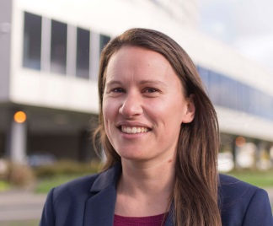Megan Collins** is a coastal and water resources engineer based in the Oakland AECOM office. She has 10 years’ experience in the field of civil and environmental engineering with a focus in marsh restoration design, dredging design and construction, beneficial reuse of dredged material, dam removal, river and inter-tidal system hydrodynamic modeling, environmental permitting, and industrial stormwater treatment. Current projects include the South Bay Salt Pond Restoration Project at the Southern Eden Landing Ponds and the Searsville Dam & Reservoir Alternatives Study in Santa Clara County. Mrs. Collins obtained her MS and BS in Civil and Environmental Engineering from Stanford University, with a focus in environmental fluid mechanics and hydrology. She has also earned a coastal engineering certificate from Old Dominion University.

**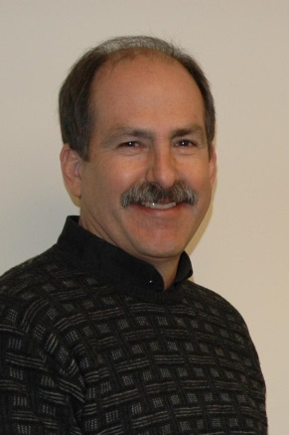David Doak** has been employed with the U.S. Army Corps of Engineers at the San Francisco District office for the last 19 years, where he serves as the Navigation Technical Manager in the District’s Engineering Branch. He provides engineering technical oversight and quality control for the District’s dredging projects, as well as coordination and collaboration with the resource agencies, non-governmental organizations, and project stakeholders. David also participates in the Long Term Management Strategy (LTMS) effort to reduce in-bay placement and maximize beneficial use of dredged material, while ensuring the most cost effective manner of dredging.

He holds a Bachelor of Science degree in Civil Engineering from the University of New Mexico in Albuquerque and he is a registered Professional Engineer in the State of California.

Mr. Doak is the former Project Manager and lead engineer for the Oakland Harbor -50-foot Navigation Improvement Project that was completed in 2010 and also received the “Transportation Project of the Year” award from the regional chapter of the American Society of Civil Engineers (ASCE) in 2010. This project removed approximately 12.5 million cubic yards of dredged material from the Oakland inner and outer harbors and placed approximately 95 percent of it in beneficial use sites. These beneficial use sites include the federal wetland restoration project at the former Hamilton Army Airfield in Novato, the privately developed Montezuma wetlands site in Collinsville, and the ongoing construction at the Middle Harbor Enhancement Area (MHEA), which will provide aquatic habitat at the Port of Oakland. The MHEA design has also been awarded the “Engineering Excellence” award for 2011 by the ASCE.

**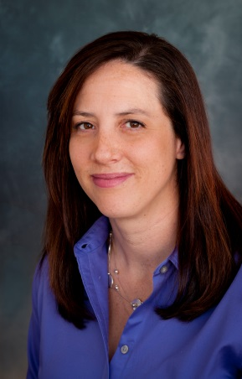Jaclyn Gnusti** is a civil engineer with Anchor QEA, LLC, in San Francisco. For the past 18 years, she has specialized in the planning, design, cost estimating, contracting, and construction support of dredging projects. Her work has spanned the Gulf Cost, New York, British Columbia, and Africa; however, her core dredging focus has been the dynamic and complicated environment of the greater San Francisco Bay Area. Her regional project experience ranges from deepening and new work planning of very large deep-water ship channels to maintenance dredging of small shallow-water marinas and docks. In her role as the chair of the Dredging and Beneficial Reuse Committee, her focus has been to develop and support regional initiatives that balance both environmental and economic responsibility.

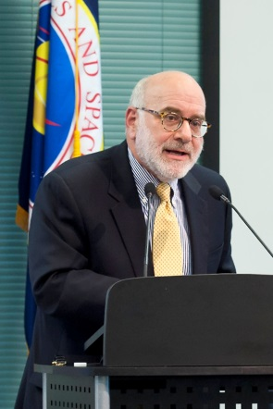**Larry Goldzband** joined BCDC as Executive Director in August 2012. Prior his appointment, Larry worked for members of both the U.S. House of Representatives and the U.S. Senate, was Chief Deputy Cabinet Secretary for former Governor Pete Wilson, and was Director of the California Department of Conservation. In the private sector, he managed Pacific Gas and Electric Company's charitable contributions program for over ten years and was Executive Director of the PG&E Corporation Foundation until July 2010. In the nonprofit sector, Larry was Policy Director for Efficiency First California prior to starting at BCDC. In addition, Larry twice served as a BCDC Commissioner for a total of almost ten years. Larry received his undergraduate degree from Pomona College and his MBA from the Kellogg Graduate School of Management at Northwestern University.

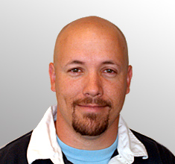**Josh Gravenmier** is a Principal Scientist / Technical Expert with ARCADIS in Walnut Creek, California with more than 25 years of experience in the environmental science and consulting space. Specialties include the oil and gas industry; sediment evaluation and dredging programs; emergency prevention, planning and response; brownfield redevelopment; and program oversight for public and federal clients. He is a program manager with extensive experience designing, implementing, managing, permitting, and interpreting extensive sediment evaluations as well as providing environmental compliance during sediment construction management and restoration. Mr. Gravenmier also serves as a Regional Manager for the ARCADIS’ Emergency Response and Recovery Service Team and he has been an active member of the Bay Planning Coalition for many years, currently serving on the Board of Directors as an Executive Board Member and on the Dredging and Beneficial Reuse Committee.  
\

**X:\BPC Documents\WORKSHOPS - BRIEFINGS\2016\WORKSHOP - Dredging and Beneficial Reuse\Speakers\Bios and Photos\YES_BETH HUNING\PastedGraphic-2.tiffBeth Huning** is the Coordinator of the San Francisco Bay Joint Venture, a public-private partnership for wetlands protection and restoration. She has been actively involved in wetlands conservation in the Bay Area over 30 years, including 18 years with the National Audubon Society in various capacities and as the director of Richardson Bay Audubon Center & Sanctuary when she helped found and chair the Joint Venture. She holds a BA in geography and was honored in 2001 as a Fellow by the Stanford Graduate School of Business Center for Social Innovation for non-profit management. In her free time, she hikes, kayaks, dances, photographs, and travels the world. An accomplished photographer, she is the 2011 recipient of the North American Nature Photography Association’s Philip Hyde Grant award for conservation photography.

**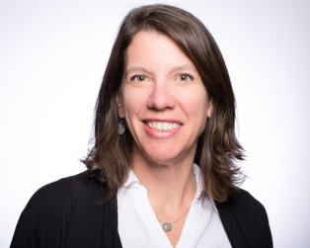Amy Hutzel** is a Deputy Executive Officer at the Coastal Conservancy, which works to protect open space, increase public access and recreation, and restore wildlife habitats along the Coast and in the Bay Area. She worked in the San Francisco Bay Area Program of the State Coastal Conservancy for 15 years, on such projects as the Hamilton Restoration, Napa River Salt Marsh and the South Bay Salt Ponds. She is the current chair of the San Francisco Estuary Partnership and the Bay Area Ecosystems Climate Change Consortium. She has a bachelor degree in urban and environmental planning from the University of Virginia.  She worked as an educator at the San Francisco Bay National Wildlife Refuge, Kilauea Point National Wildlife Refuge, and Save The Bay prior to joining the Coastal Conservancy.

**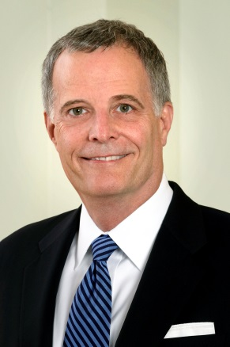David Ivester** focuses on land use, environmental, and natural resource law. He has represented landowners, developers, public entities, energy companies, and various other businesses on a wide variety of environmental, land use, land title, and water quality issues before federal, state, and local regulatory agencies and state and federal trial and appellate courts. David has frequently lectured and written about environmental and land use regulation.

David regularly represents clients in federal, state, and local regulatory agencies on land use, environmental review, wetlands, endangered species, water quality, and natural resource issues. He has broad experience with the U.S. Army Corps of Engineers, Environmental Protection Agency, U.S. Fish and Wildlife Service, National Marine Fisheries Service, Federal Energy Regulatory Commission, California Department of Fish and Game, State Water Resources Control Board and the Regional Water Quality Control Boards, California Coastal Commission, California Energy Commission, San Francisco Bay Conservation and Development Commission, and cities and counties.

David’s litigation experience includes federal and state suits involving the Clean Water Act, Endangered Species Act, National Environmental Policy Act (NEPA), Federal Flood Insurance Act, Rivers and Harbors Act, California Environmental Quality Act (CEQA), California Endangered Species Act, Fish and Game Code, Porter-Cologne Act, Permit Streamlining Act, and regulatory takings under the U.S. Constitution.

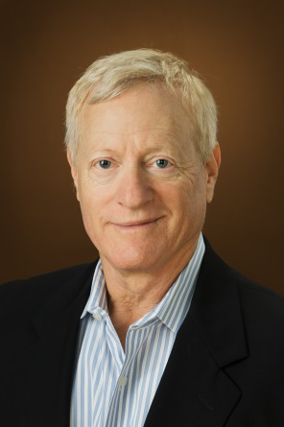**Jim Levine** is a Bay Area entrepreneur with a UC Berkeley graduate degree in environmental engineering. For four years, during and after graduate school, Jim was a proud member of the staff of the RWQCB in Oakland, working there on emergency response, site cleanup, and treatment plant field operations and recovery.

Jim then went on to co-found the Levine\*Fricke group of companies, of which the US-wide environmental consulting and contracting firm was sold in 1998. Levine\*Fricke successfully remediated California’s first Superfund site, worked on over 2,500 projects and worked with the US Army and Navy to pioneer technologies to stabilize nuclear materials.

Twenty years ago, Levine began the Montezuma Wetlands restoration project, helping to pioneer the use of dredged sediment to accelerate the restoration of tidal wetlands and other habitat, influencing federal policy on dredging, wetlands and funding around the country. Montezuma has since received close to 7 million cubic yards of sediment while readying the first 500-acres of wetlands for full restoration.

For four years, Jim served as the Legislature’s appointed Commissioner to the SF Bay Conservation and Development Commission, served as a Trustee for the Oakland Children’s Hospital, a board member for organizations helping at-risk youth, a long-time trustee for Ecole Bilingue of Berkeley, and was a long-time advisory board member for UC Berkeley’s College of Engineering. Jim is currently a member of the Bay Area Council Executive Committee and co-chair of the Council’s Water Committee. He has also served as a long-time Board member for the Bay Planning Coalition.

Jim has also worked as an owner, developer, consultant and mediator on real estate projects over the past fifteen years.

**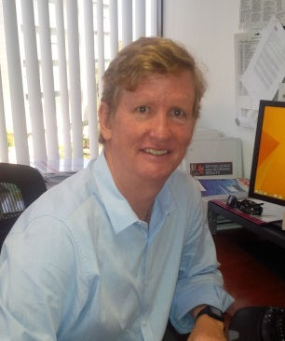Jim McNally** is Manson Construction Co.’s Executive Vice President and West Coast Regional Manager. He has 30 years of experience as a civil engineer in the dredging and marine construction industry. He oversees the management of four business units contributing roughly half of Manson’s annual revenues and also oversees Manson’s Equipment group, supporting the management of Manson’s national fleet of dredges, derricks and support vessels. Jim’s Bay Area Dredging experience includes oversight of the completion of the Hamilton Wetland project, including the negotiation of a contract extension with the USACE SF District to provide unloading services for various O&M projects. Jim has been directly responsible for the execution of Manson’s dredging work in the Bay since 2009. Prior to joining Manson, Jim spent 4 years with Moffatt & Nichol and 19 years with Great Lakes Dredge & Dock, where he managed major deepening projects such KVK4A in NY, Pier 400 in Los Angeles and Phase 3b&c of the Oakland Deepening. Jim has a BS in Civil Engineering from the University of Rhode Island. He has also completed the Executive program at UCLA’s Anderson School of Business. Jim currently lives in Irvine, California.

**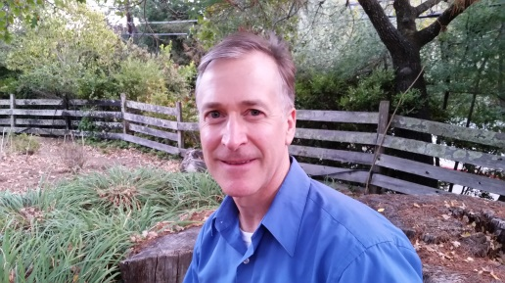Jeff Melby** is a Project Manager at the Coastal Conservancy, and manages the Hamilton/Bel Marin Keys Restoration Project, Dutch Slough Restoration, and several other grants and projects in the San Francisco Bay Area to protect and restore habitats and provide public access opportunities. He has 30 years of experience in environmental investigation, remediation, protection, conservation and restoration. He has a Bachelor’s degree from Cornell University, a Master’s in Hydrogeology, and is a California Professional Geologist and Certified Hydrogeologist.

**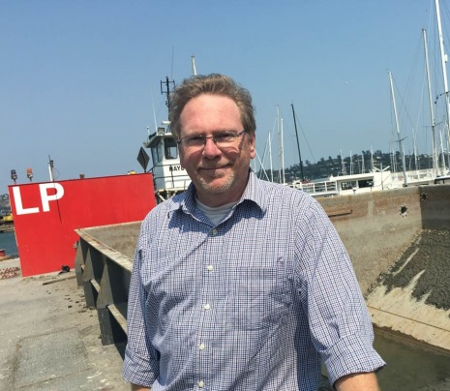Brian Ross** has been with EPA for over 30 years. Brian’s degrees are in Fisheries Science from the University of Washington where he studied the effects of the Mt. St. Helens eruptions on salmon runs. Before coming to San Francisco in 1991 he worked in EPA’s Seattle office on dredging and sediment testing, and in EPA’s Alaska office working on North Slope oilfield issues and the Exxon-Valdez oil spill. He has been in the Bay area doing dredging and sediment management work since 1991, and was an early member of the team that developed the LTMS and the DMMO.

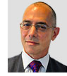**Richard Sinkoff** is the Director of the Division of Environmental Programs and Planning at the Port of Oakland. In this role, Mr. Sinkoff leads the Port of Oakland’s regulatory, environmental compliance, safety and permitting programs for the seaport, Oakland International Airport and the Port’s commercial real estate division.

In 2007-2009, Mr. Sinkoff directed the Port of Oakland’s Maritime Air Quality Improvement Plan (MAQIP). In 2012, the Port’s updated emissions inventory showed a 70% reduction in diesel particulate matter (DPM) from maritime-related mobile sources. In 2010, Mr. Sinkoff directed the Port of Oakland 5-year Strategic Plan.

Mr. Sinkoff is a Board Member of the Bay Planning Coalition, an Oakland-based maritime industry coalition that advocates for sustainable commerce, industry, infrastructure, recreation and the natural environment connected to the San Francisco Bay and its watershed. In 2014, Mr. Sinkoff was elected Vice President of the Bay Planning Coalition for a two-year term.

Mr. Sinkoff is a graduate of Columbia University (BA, Urban Studies and Architecture History, cum laude) and UC Berkeley (Master of City Planning). In 2006, Mr. Sinkoff completed his Juris Doctorate (JD) from Golden Gate University School of Law in San Francisco, where he was awarded the Grotius Award for Academic Excellence in International Law.

Mr. Sinkoff is an avid swimmer, cyclist, and skier and enjoys year-round hiking in California and summer ascents in the High Peaks Region of New York State’s Adirondacks.

**UPCOMING BPC EVENTS**

**BPC Annual Meeting & Luncheon**

Friday, December 9, 11:00 am – 1:30 pm

St. Francis Yacht Club, San Francisco

**BPC MEMBER COMMITTEES**

**Dredging & Beneficial Reuse**

**Legislative & Policy**

**Marinas & Boatyards**

**Membership**

**Organizational Development**

**Sustainable Waterfronts**

**Water, Energy & Infrastructure**

**THE DREDGING & BENEFICIAL REUSE WORKSHOP IS GENEROUSLY**

**SUPPORTED BY**

****

**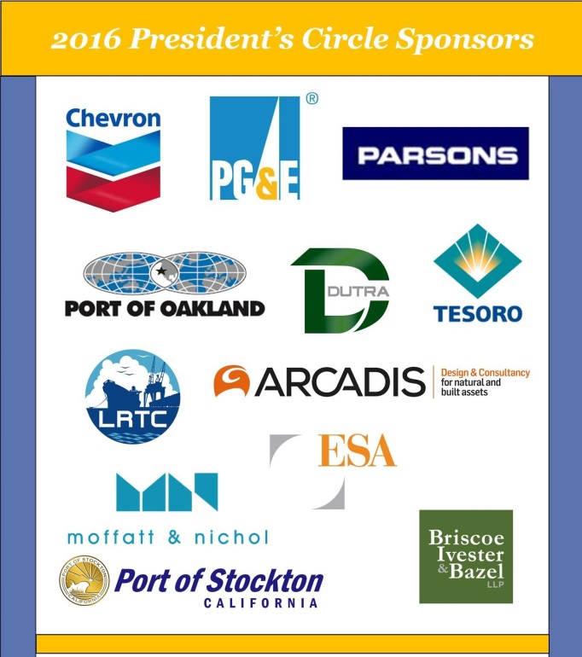**

**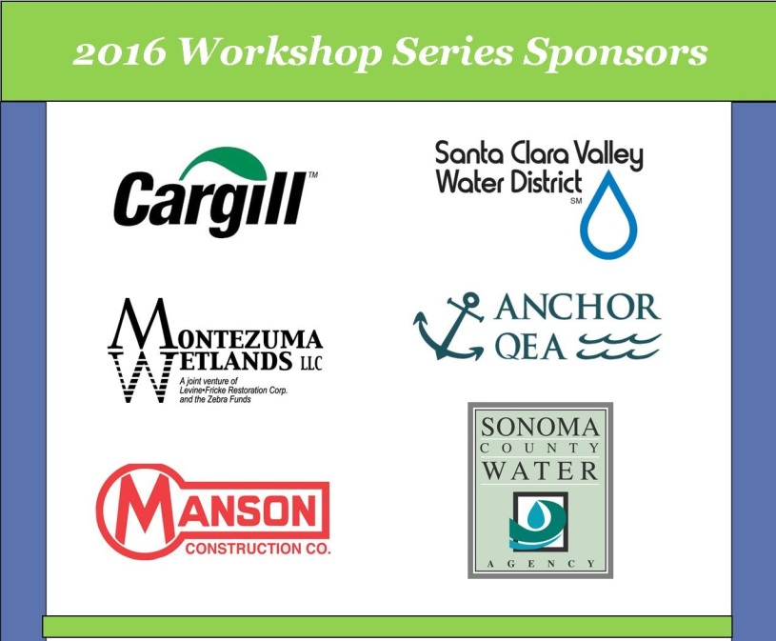**

*Thank you for joining us today. Please let Bay Planning Coalition staff know if there is anything we can do to improve your experience at the Dredging & Beneficial Reuse Workshop.*

*We hope to see you at another BPC event soon.*