Development of LIMITED-MUN Beneficial Use Designation
Flow Chart 1 –Categorization of Ag Dominated Surface Water Bodies
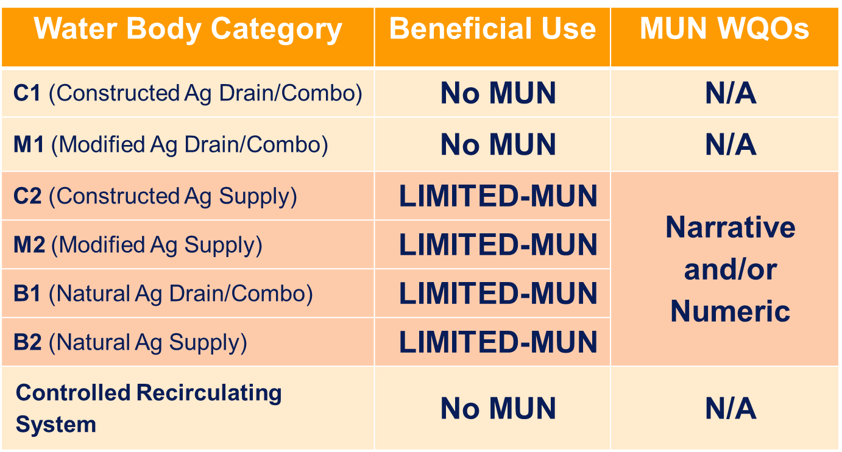
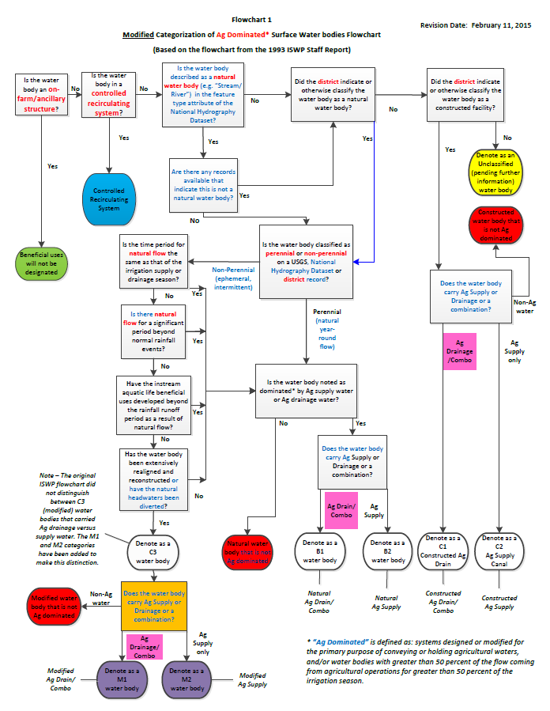
Primary Topic for Discussion
Definitions
Selection Criteria
Water Quality Objective – language

Table 1. Proposed MUN Beneficial Use Designations document)
Water Body Categorization Report and Regional Board Staff review

Potential Options for the LIMITED-MUN Beneficial Use Definition:
LIMITED – MUN Beneficial use

- Non-potable uses of water for community, military, or individual water supply systems.
- Uses of water that are part of agricultural activities and support non-potable uses of water for community, military, and or individual water supply systems.

- Uses of water for municipal and domestic supply in agriculturally dominated surface water bodies resulting from management activities and/or water treatment beyond conventional treatment.
Management activities may include but are not limited to wheeling water year-round, blending, prohibiting ag drainage into the water body and limiting maintenance activities. Treatment beyond conventional may include but not be limited to ion exchange and reverse osmosis.
- Uses of water for municipal and domestic supply in agriculturally dominated surface water bodies where full use is limited by physical conditions such as intermittent flow conditions and/or elevated natural background constituent concentrations.
- Uses of water for municipal and domestic supply in agriculturally dominated surface water bodies where full use is limited by inherent conditions such as intermittent flow, management to maintain intended use of a constructed facility and/or constituent concentrations in source water.

Draft Selection criteria for a LIMITED-MUN water quality objective:
- Maintain consistency with federal and state water quality laws and policies as applicable (e.g. Sources of Drinking Water Policy, Anti-degradation Policy)
- Provide the appropriate protection of MUN in an Ag dominated surface water body with consideration given to the current and potential future uses
- Assure compliance with all relevant water quality objectives downstream.
- Allow constructed Ag dominated water bodies to be utilized for their intended design and purpose
Example - Irrigation Supply Channels
- Make efficient (reasonable) use of Central Valley Water Board and stakeholder resources to develop and implement water quality standards

- Provide flexibility to address naturally elevated background constituents

Table 2. Draft Water Quality Objective Options for a “LIMITED MUN” Category
Water Quality Objective Options | Brief Description | Level of Consistency with Selection Criteria  Ratings = Yes/No or High/Medium/Low |  |  |  |  |  | Notes
 |  | 1 (Laws) | 2 (Potential Use) | 3 (Downstream Protection) | 4 (Intended Use) | 5 (Reasonable use of resources) | 6 (Background levels)
Add new NARRATIVE water quality objective | A narrative water quality objective is given in the Basin Plan for the LIMITED MUN beneficial use  Proposed Options:  - Accumulation of constituents in the water body must not unreasonably affect non-potable water use. | Yes | Low | Low | Med | Med | Low | - How is accumulation determined?  - “Non-potable” is a very broad term; may be difficult know whether or not the water body is protected
 | - Accumulation of constituents in the water body must not unreasonably affect non-potable water use or degrade other in-stream or downstream beneficial uses. | Yes | Low | High | Med | Med | Low | - “Non-potable” is a very broad term; may be difficult know whether or not the water body is protected  - Considers in-stream and downstream beneficial uses
 | - Accumulation of constituents in the water body must not unreasonably affect non-potable water use and cannot preclude potable use with reasonable management and/or treatment. | Yes | Med | Low | Med | Med | Low | - “Non-potable” is a very broad term; may be difficult know whether or not the water body is protected  - “potable use” may result in the use of primary and secondary MCLs as water quality objectives  - “reasonable” may require examples
 | - Accumulation of constituents in the water body above natural background concentrations cannot preclude managed and/or treated use of the water for Municipal or Domestic Supply (MUN) use or degrade downstream beneficial uses | Yes | Med | High | Med | Med | High | - Need to define “natural background concentrations”  - Need examples of “managed and/or treated” and some concept of relative and acceptable economic cost.
 | - Accumulation of constituents in the water body must be found to provide maximum benefit to the people of the state and not unreasonably affect managed and/or treated use of the water for Municipal or Domestic Supply (MUN) use nor degrade downstream beneficial uses above natural background concentrations. | Yes | Med | High | High | Med | High | − Includes reference to maximum benefit of the people of the state - Antidegradation  − Need to define “natural background concentrations”
 | - Discharge from these water bodies will not degrade downstream beneficial uses consistent with the state antidegradation policy (SWRCB Resolution No. 68-16). | Yes | Low | High | High | Med | Low | - Does not protect the water body itself  - Already an existing legal requirement
 | - Water quality will be protected as specified in the state antidegradation policy (SWRCB Resolution No. 68-16). | Yes | Med | High | Med | Med | Med | - Refers directly to Antidegradation policy  - May be able to provide clarification in implementation section  - Already an existing legal requirement
 | - Water quality will be protected consistent with the state antidegradation policy and will not negatively impact downstream beneficial uses. | Yes | Med | High | Med | Med | Med | - Refers to Antidegradation policy but without the policy number (in case it ever changes)  - May be able to provide clarification in implementation section  - Already an existing legal requirement
Add new NUMERIC  water quality objective | A numeric water quality objective is given in the Basin Plan for LIMITED MUN  Proposed Options:  - Must meet primary MCLs, but not secondary MCLs. (Narrative for nuisance objective will still apply) | Yes | Med | Med | Low | Low | Low | - Secondary MCLs are for taste, odor and appearance, and do not reflect a human health criteria  - Water purveyors still must report exceedances to secondary MCLs in source water to the public
 | - Must meet primary and secondary MCLs with the exception of: trihalomethanes (short half-life) | Yes | High | High | Low | Low | Low | - Trihalomethanes have a short half-life and are a low human health threat in waters that are not currently being used for the MUN use.  - MCLs are tap water standards and these objectives are restrictive for agricultural practices  - Removing trihalomethanes or other constituents would require constituent by constituent scientific justification
 | - Must meet primary and secondary MCLs, but dissolved fractions can be used in place of total fractions | Yes | High | High | Low | Low | Low | - Using dissolved fractions reflects the use of filtration in conventional water treatment  - Water purveyors use total fractions for reporting secondary MCL values  - May be over-restrictive for potential MUN use of the water body itself.

Table 3. Developing the Implementation Program for LIMITED-MUN
Factors to Consider  (when determining potential degradation) | Discussion Items/Questions | Proposed Implementation Language
Source and Receiving Water Quality | - Is the source water different from the receiving water (if any)?  - What type of characterization should be conducted?  - Evaluate for natural vs. anthropogenic sources of constituent concentrations?  - Should intake credits apply?  - Other? | Suggestions?
Physical Hydrology | - Constructed or natural water body? Would we treat them differently?  - Should water volume and flow patterns be addressed?  - Other? | Suggestions?
Current Management (e.g. Conservation, Recycling, Reuse Efforts, Maintenance) | - Is the water body part of a management area for recycling/reuse?  - What type of maintenance is required to ensure that the intended purpose of the water body is maintained? Are they all a maximum benefit?  - Other? | - Recycling and Reuse efforts are considered a maximum benefit to the people of the state as long as the discharge does not negatively impact downstream beneficial uses.  - Maintenance of a constructed water body for its intended purpose is considered a maximum benefit as long as the discharge does not negatively impact downstream beneficial uses.
Potential for Contaminant Accumulation | - Periodically hold a public review of water bodies designated LIMITED-MUN to evaluate cumulative impacts and include a reopener in permits to include any necessary revisions to permit conditions that result from the evaluation? (e.g. every 10 years?)  - Other? | Suggestions?
Potential Impact on Downstream Beneficial Uses | - Where is the first MUN water body downstream? How far is the LIMITED-MUN water body from the first MUN water body? Allow for attenuation and/or dilution credit for permit limits?  - Other? | Suggestions?
Other | - To maintain existing conditions and to protect downstream beneficial uses, use primary and/or secondary MCLs as a trigger to do an Antidegradation Analysis? Do not use primary and/or secondary MCLs for compliance or enforcement provisions/actions on these water bodies.  - Other? | Suggestions?

