EBMUD First US Plant to Produce more Energy than it Uses
0
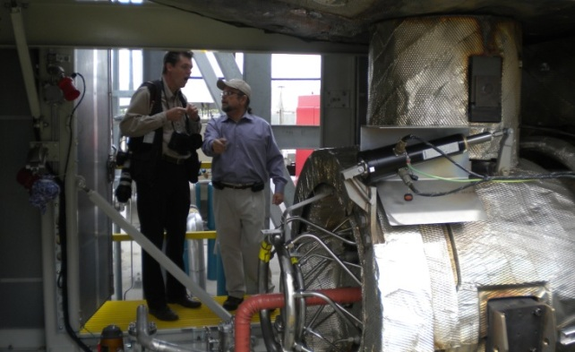
4.6-megawatt low-emission turbine nearly doubles EBMUD's power generation
On April 3, East Bay Municipal Utility District unveiled its newest green technology. A state-of-the-art turbine nearly doubles the utility’s capacity to produce clean energy from waste previously thought to be too gross, too toxic and too difficult to manage. Now, communities across the nation are following EBMUD’s lead and developing similar programs to convert organic waste material into renewable energy.
Alexis Strauss, director of EPA Region 9 Water Division, John Coleman, president of EBMUD’s Board and Matt Bond, president of WEF, were all on hand to talk about EBMUD’s commitment to the environment and renewable energy.
The recent expansion of its power plant and aggressive collection of food waste to feed it has put the utility in a class by itself, said Bond. He called the $32 million power plant expansion a model for the industry because it helps eliminate problematic waste streams, reduces greenhouse gases and is a good deal for ratepayers.
“Instead of thinking of what we do as waste disposal, we are beginning to understand that wastewater treatment plants can be recyclers and, in fact, generators of valuable commodities like renewable energy, recycled water, compost, nutrient fertilizers, and even biodiesel,” Bond said at a ceremony to launch the new turbine.
The agency delivers water to 1.3 million customers and treats sewage from the East Bay communities of Alameda, Albany, Berkeley, Emeryville, Oakland, Piedmont, El Cerrito, Kensington and part of Richmond. Over the past 60 years, EBMUD’s programs have evolved and today the emphasis is on preventing pollution at the source and finding ways to generate energy and reuse elements from the waste stream. All while protecting public safety and the San Francisco Bay’s health by managing wastewater and wet weather flows.
The agency collects discarded food and solid waste at its main wastewater treatment plant near the eastern end of the Bay Bridge. The muck is tossed into a digester that creates methane through microbial processing, which in turn can power electricity-generating machines. Methane causes 23 times as much damage as carbon dioxide toward global warming, so capturing it makes a big impact toward sustainability.
Since 1985, the district has been using three conventional engines – each about the size of a car – that run on the methane to make electricity to power half of its operations. The new turbine is more compact, able to fit in the bed of a truck, and has a 4.6-megawatt capacity compared with the existing three engines whose combined capacity is 6.3 megawatts. “It’s basically a jet engine,” Coleman said. “It’s just a lot more efficient.” That means fewer methane burn-off flares and the potential to sell renewable energy generated from waste back to the grid. It will also save the District 3 Million in energy bills.
Other Northern California utilities are following EBMUD’s lead, particularly in establishing food waste recycling facilities. They don’t have to reinvent the wheel now,” Strauss said, adding, “They will eventually become a competitor for that food waste.” The District started accepting food scraps in 1991 and has developed a patented process to manage the waste including an innovative outreach campaign to educate its partners on what waste can be recycled. About 120 trucks deliver scraps from the wine, cheese and restaurant industries for reuse.
CWEA member and EBMUD Engineer John Hake lead a tour of the facility. Check out the photos:
[Show as slideshow]
[View with PicLens]
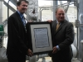
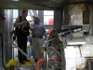
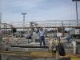
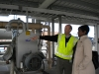
Posted by Lola Dvorak on Wednesday, April 4, 2012 at 1:19 pm
Filed under Agencies in the News, Top Featured · Tagged with

