PRESS RELEASE
Marine Recreation Association

Contact: Mariann Timms  Telephone: 209-334-0661  Email: mra@marina.org  Website: http://marina.org | FOR IMMEDIATE RELEASE  December 5, 2017
SAVE THE DATE !!! 3rd Annual ‘California Boating Congress’ set for February 27 - 28, 2018 at CA State Capital
The 2016 CBC set the bar, and last year’s California Boating Congress proved the value of communication between boaters, the marine industry, and California state legislators and regulators . . .
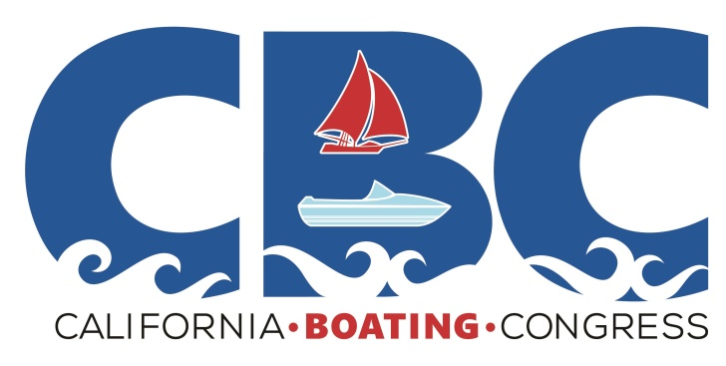
The Marine Recreation Association is again sponsoring the California Boating Congress, where the marine industry and boating community come together at the State Capital to advocate for issues affecting this important part of our state’s economy and culture, and “chart the future of boating policy in California.”
“Based on the success of the last two California Boating Congresses, and the participation of three additional co-hosts for this year’s event, we are expecting the 2018 CBC, and our voice at the Capital, to grow substantially,” said Mariann Timms, MRA Operations Administrator.

This year’s Congress will kick off Tuesday evening, February 27th, with a cocktail reception for attendees at the Hyatt Regency Sacramento, 1209 L. Street, Sacramento, CA 95814, with the main event commencing Wednesday, February 28th at the Hyatt Regency at 8:30 AM.

A keynote speaker, and summary of legislative issues will be featured in the morning, followed by breakout sessions focused on specific key issues, and legislator meeting instructions. Lunch will be served at the Hyatt, and then attendees will proceed to the State Capital for meetings with individual legislative representatives throughout the afternoon. Opportunities to meet with state representatives will be scheduled by organizers, and early registrants will get priority for scheduling with their State Legislators, so mark your calendar for February 27 – 28, 2018, and plan to register EARLY!

This important public event is the result of collaboration between the MRA and eleven other boating related groups, including the Worldwide Boaters Safety Group, California Yacht Brokers Association, National Marine Manufacturers Association, California Marine Affairs and Navigation Conference, Personal Watercraft Industry Association, California Sportfishing League, California Delta Chambers & Visitors Bureau, Recreational Boaters of California, Bay Planning Coalition, Sacramento Valley Marine Association, and California Association of Harbor Masters & Port Captains.

The 2018 CBC will be a great opportunity for all interested parties, to meet with state legislators and government regulators to discuss the impact of regulations, policies, and planning that affect recreational boating and other marine concerns in the state.

Planning is still underway for the event so watch your mail closely. Additional information will be posted soon online at www.calboatingcongress.com or contact Mariann Timms at 209-334-0061.

The Marine Recreation Association is a professional organization that represents marina owners, operators, and industry professionals located throughout the western United States with additional members in Canada, Mexico, and Australia. Created more than 46 years ago, the MRA actively promotes and represents recreational boating interests while providing educational management and operations seminars, and information for marine industry owners, operators, and staff.

For additional information about the MRA, and all of its activities and interests, please contact Mariann Timms by phone at (209) 334-0661, email at mra@marina.org or go online at http://www.marina.org.

