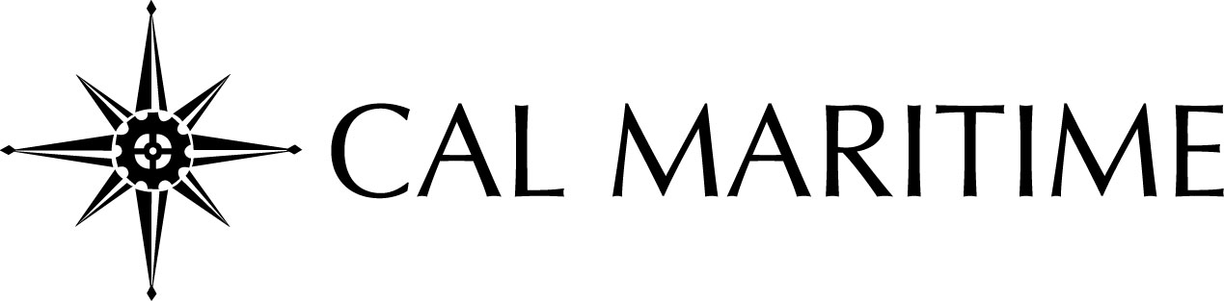

Greetings!
Please accept our invitation to promote your company at our 2015 Fall Career Fair on Tuesday, October 27th from 9:00 am to 2:00 pm. This event is your opportunity to educate students about your business, company profile, corporate culture and possible career paths within your organization. We invite you to reserve space at this event as it is a great opportunity to get your company recognized and to outreach to future employees.

The California Maritime Academy offers six baccalaureate degrees and one graduate degree:

- Business Administration
- Global Studies and Maritime Affairs
- Facilities Engineering Technology
- Marine Engineering Technology
- Mechanical Engineering
- Marine Transportation
- Transportation and Engineering Management (Graduate Degree)

We educate and train managers, engineers and officers for our nation’s maritime industries and businesses.

To help make your recruiting day a success, please keep in mind the information listed below:

- Recruitment Table – Space is limited; register your company early.
- Parking – is limited; we encourage recruiters to carpool.
- Lunch – is provided; refreshments will be served throughout the day and may include: coffee, water, sodas, pastries and cookies.
- Shipping – If shipping booth or materials in advance, it must arrive no later than Friday, October 23, 2015 (refer to shipping address on the registration form).
- Sponsorship – This opportunity is designed to provide maximum exposure for your company. Recognition will be in the form of additional advertisement in the Career Fair program, a large company sign at the event and one premium parking space
- Deadline – Registration form and payment must be received by Friday, October 16th to secure your recruitment table.
- Registration – The registration fee will be waived for all government agencies, non-profit agencies and graduate schools for the 2015 Fall Career Fair.

If you have any questions regarding the registration process for the Career Fair, please email or call:

Tess Luna
Career Fair Coordinator
careerdevelopment@csum.edu
707-654-1071

We look forward to hosting you and your company at Cal Maritime’s 2015 Fall Career Fair.

Thank you!

